**Experiment No: 08**

**Experiment Title**: Arduino with LCD and Keypad key Pressed will be displayed in LCD Screen

**Theory:** This circuit is the basic circuit for Arduino projects with LCD Display. I will use any Arduino flavor for this circuit, but just remember to put a current limiting resistor between the pin 16 of the LCD Display to GND. Also, if I want you can connect a 10k ohm Potentiometer to pin 3 of the LCD Display, remember you need to connect pin 1 of the POT to VCC - 5V and pin 2 of the POT to GND.

Firstly, I will set the Arduino and I will place a LCD light Monitor. Then I will connect this LCD monitor to the Arduino connection line and set also a keypad to connection the product with Arduino and LCD monitor. So, we will connect and start or simulate this project the LCD is working here.

**Code:**

#include <Keypad.h>

#include <LiquidCrystal.h>

LiquidCrystal lcd (5, 4, 3, 2, A4, A5);

const byte ROWS = 4;

const byte COLS = 4;

char keys [ROWS][COLS] = {

{'1','2','3','A'},

{'4','5','6','B'},

{'7','8','9','C'},

{'*','0','#','D'}

};

byte rowPins [ROWS] = {A0, A1, 11, 10};

byte colPins [COLS] = {9, 8, 7, 6};

int LCDCol = 0;

int LCDRow = 0;

Keypad keypad = Keypad (makeKeymap (keys), rowPins, colPins, ROWS, COLS);

void setup () {

Serial.begin(9600);

lcd.begin (16, 2);

lcd.setCursor (LCDCol, LCDRow);

}

void loop (){

char key = keypad.getKey ();

if (key){

Serial.println(key);

if ( LCDCol > 15 )

{

++LCDRow;

if (LCDRow>1)

{ LCDRow=0; LCDCol = 0 ; lcd.clear(); }

LCDCol = 0 ;

}

lcd.setCursor (LCDCol, LCDRow);

lcd.print (key);

++LCDCol;

}

}

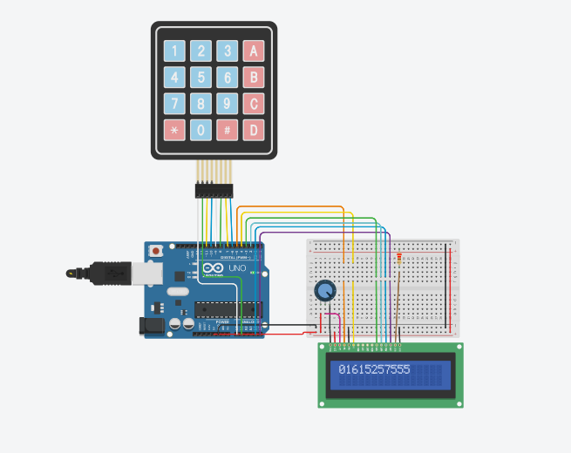**Output:**

**Conclusion:**

1. We will learn how to set up Arduino board and lcd monitor and also keypad to input.
2. We will also learn how to connect this Arduino board and also keypad with lcd to show output.
3. We will also learn how to display output to use lcd monitor.